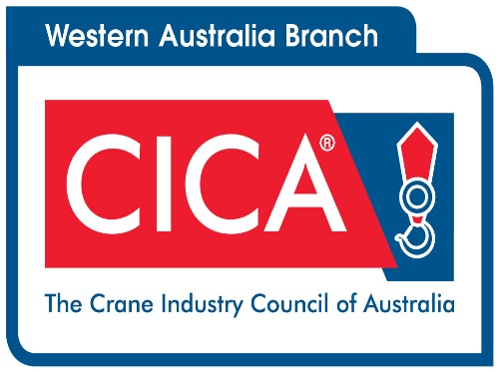 The Crane Industry Council Association of WA presents

*ANNUAL DINNER NIGHT* 31st July 2021

Frasers Resraurant -Kings Park

6.30pm 

***Contact Details***

Name ____________________________________________________________________

Company _________________________________________________________________

Tel ___________________________ Email _______________________________________

***Attendees*** (Please indicate if vegetarian meals are required)

1. __________________________
2. __________________________
3. __________________________
4. __________________________
6. __________________________
7. __________________________
8. __________________________

***Payment Details*** Members: $75 (GST Inc) | Table of 10 $750 (GST Inc)

\**This includes Canapes a 3 course meal plus Beer, Wine & Soft Drinks.*

|  |  |
| --- | --- |
|  |  |
|  |  |
| 1. | 🞎 Visa 🞎 MasterCard  ------------------ / ------------------ / ------------------ / ------------------ ---------------- /----------------  (card number) (expiry) ( cvv)    ------------------------------------------------------------------------  (name on card) |
| 2. | EFT - please pay to bank account A/C Name: Crane Industry Council of Australia BSB:313-140 A/C 1200 2214  REF:2021 WA Dinner **And then email remittance advice to cicawa@casm.com.au**    T: 08 9427 0840 | F: 08 9427 0801PO Box 8463, Perth Business Centre, WA 6849 | 36 Brisbane Street, Perth, WA 6000Web: [www.cicawa.com.au](http://www.cicawa.com.au) | email: [cicawa@casm.com.au](mailto:cicawa@casm.com.au) |